There have been some issues with adding blocks in CoPath. Sometimes it’s helpful to add a block so all the stains are copied (ie any sentinel lymph node), but sometimes you only want 1 H&E and not the frozen or LDX panel. This can severely impact histology and subsequently the pathologists with delayed cases as well as too many or too few blocks depending what they wanted. With the addition of the frozen slides please do not copy the stains from a frozen block--- this gives each subsequent block 2 frozen labels.

Also, from this window you can add a comment to the block, but you will need to go to Block Detail to add “other block number” in the event you need it to say “BRS, LDX, SNB, SNM, SNE, DERM, etc” if the 1st block does. This helps histology when cutting and triaging their work.

Here’s how to do each one:

COPYING THE STAINS
-Histology Data Entry/Edit
-Histology Tab (to see the stain list for each block)
-Blue arrow needs to be on the part type (top) and block (bottom left) you want to copy
-At the bottom add 1 block or more blocks knowing ALL blocks will copy ALL stains under the highlighted block

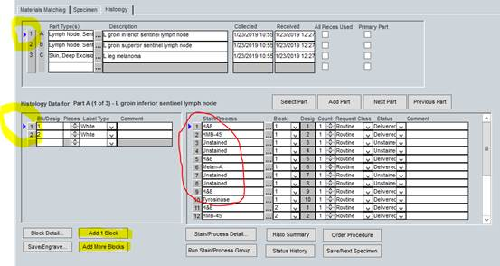

ADDITIONAL BLOCKS 1 H&E
-Histology Data Entry/Edit
-Histology Tab (to see the stain list) (if all are H&E can do from Materials Matching tab, but make sure!)
-Blue arrow needs to be on the part type (top) and the EMPTY ROW (bottom left)
-At the bottom add 1 block or more blocks and each will get 1 H&E

